Study Abroad in Israel
Application Form
for the Winter Semester 2023-2024

Applicant

First and Middle Name:
Last name:
Gender: female male diverse
Birthdate, Place of Birth:
Country of Citizenship:
Expiration Date of Passport:
Home Address:
Phone Number (where applicant can be easily reached):
University Email Address: @student.uibk.ac.at
Preferred Email Address - if not the Email Address above (where applicant can be easily reached!):
Matriculation Number/Student Number at LFUI:
Field of Study/Studies in English and German:
Program of Study/Studies (BA, MA, Diploma, Teaching Program, Other):
In which semester will you be in during the winter semester 2023-2024 (number of semester)?
Degree Earned (for MA and PhD students only):

I am applying for the Winter Semester 2023/2024 yes other

Please rank your preferred partner universities (maximum of three):
[Bar-Ilan University, Beit Berl College, Ben-Gurion University, Holon Institute of Technology, Reichman University (former IDC Herzliya College) - not Erasmus, ORT Braude College (only summer semester), Tel Aviv University, The Hebrew University of Jerusalem]
1. 2. 3.
Emergency Contact

First and Last Name:
Relationship of Contact Person:
Phone Number:
Email Address:
Address:

Study Abroad Information
Did you previously participate in any exchange/mobility activity (for example Erasmus etc.)? If yes, please indicate the program, date and length:

Please write one to two paragraphs, stating your reasons for your application to study in Israel:

Statement of Costs

How much money do you overall estimate to spend for your semester abroad?

How do you plan to finance your semester abroad?
Please indicate your family’s total annual netto household income:

I will apply for a scholarship (additionally to the Erasmus+ scholarship) at (name of institution/department). Amount granted: yes no reasons:

I receive a study grant (Studienbeihilfe, Bafög etc.): yes no
If yes, how much do you get?
Any other information or comments:
If you are a student with special needs, please state so in the above field for comments.

City, Date Signature of the Applicant

Please submit your COMPLETE application no later than
April 10, 2023 for the Winter Semester 2023/2024
via email to: aiani@uibk.ac.at

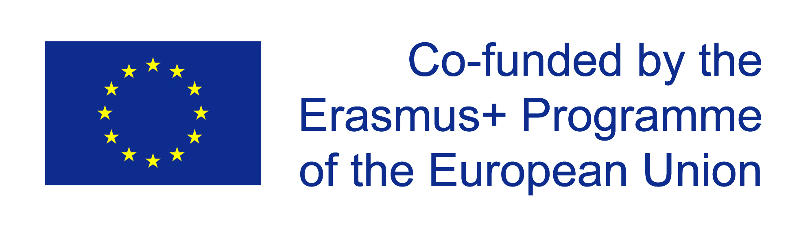
AIANI - Austria-Israel Academic Network Innsbruck
University of Innsbruck
Herzog-Friedrich-Str. 3
6020 Innsbruck – AUSTRIA

Datenschutz:
Ich stimme zu, dass sämtliche im Rahmen der Bewerbung und des Bewerbungsprozesses bekannt gegebenen personenbezogenen Daten von den bearbeitenden Stellen (AIANI, International Relations Office, Studienabteilung, sowie eventuell der Erasmus+ Nationalagentur im Falle der Nominierung) für Zwecke der Programmverwaltung und Evaluierung automationsunterstützt gespeichert, verarbeitet, ausgetauscht und verwendet werden dürfen. Weiters stimme ich der Weitergabe meiner Daten an die Gastuniversität im Falle einer Nominierung zu.

Ja Nein

Datum Unterschrift

Die Datenschutzerklärung finden Sie hier:
http://www.aiani.at/semester-abroad.html

