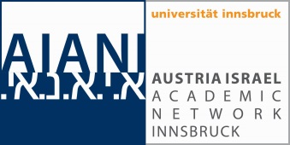
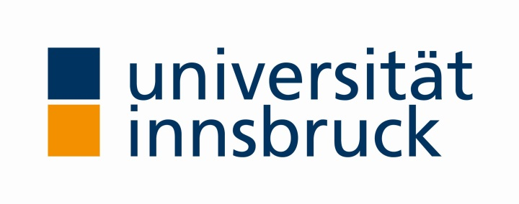
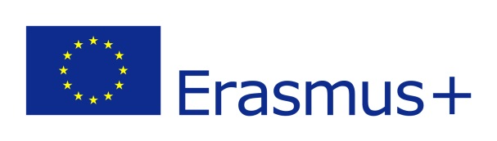
Auch für das Allgemeine Personal!

Staff Mobility
for Teaching or Training to ISRAEL
CALL for Applications for Outgoing Staff (scientific and administrative staff)
NEW! Erasmus+ Funding available for staff mobility to partner institutions in Israel for the Winter Semester 2023-2024 and the Summer Semester 2023!
The EU offers funding for faculty/staff from the University of Innsbruck to spend a maximum of seven days (5 teaching/training days and two travel days) at one of the following academic institutions within the Erasmus+ Mobility Program:
- Tel Aviv University http://english.tau.ac.il/
- Ben-Gurion University of the Negev http://in.bgu.ac.il/en/
- Bar-Ilan University https://www1.biu.ac.il/indexE.php
- The Hebrew University of Jerusalem https://en.huji.ac.il/en
- Reichman University https://www.runi.ac.il/en
- Holon Institute of Technology www.hit.ac.il/en
- Beit Berl College www.beitberl.ac.il/english
- ORT Braude College http://www.braude.ac.il/english/

Interested staff (academic and non-academic) can apply no later than August 31, 2023 for the Winter Semester 2023-2024 and the Summer Semester 2024. There are limited spots available. The program includes eight hours of teaching or ten hours of training/job shadowing at the partner institution.
Goal of the Mobility Program: connect with colleagues and students from the partner institution, establish new collaborations and ideas in teaching, research, or administrative jobs, enrich the course offerings at the receiving institution, gain experience and bring new knowledge back to the home institution, professional networking.
Language of Instruction/Training: English (or Hebrew, if the staff member knows Hebrew)
Requirements:
a. Working contract with the University of Innsbruck at the time of application and during the time of the mobility.
b. Teaching of at least eight hours or for administrative staff: ten hours of training/job shadowing
c. A stay of five days plus two travel days
d. A knowledge of English, good enough to teach a specific course or to follow the training; Hebrew is not mandatory, but basic knowledge is always welcome (courses are offered through the ISI)
e. For teaching staff: Application Form, CV, List of Publications, Course Proposal
(complete list see below)
For administrative staff training: Application Form, short CV, Job description (approx. 200 words);
statement of interest (approx. 100 words)
Staff Teaching: Staff should be willing to teach at least an eight-hour course that fits into one of the study programs at the host institution. Please Note: Course proposals need to be accepted by the receiving institution before the mobility program will be approved!
Staff Training: Staff should be willing to take part in the proposed training by the host institution and readily exchange experience and knowledge.
Amount of Funding for one stay: travel allowance of 360 Euros and 180 Euros per day. All amounts will be paid after return and after completing an online participant report!
Documents Required:
Application Forms can be downloaded here: http://www.aiani.at/erasmus-mobility
 | Staff Teaching (academic) | Staff Training (non.-academic)
Application form | yes | yes
CV (in English) | yes | yes
Course proposal or syllabus | yes | no
List of publications | yes | no
Copy of passport | yes | yes
Job description (approx.. 200 words) | no | yes
Statement of motivation/interest (approx. 100 words) | no | yes
Language Certificate | only if available | only if available
Selection of Applicants:
All applications will be viewed and ranked. Applicants will get spots as available. If there are more applicants than spots, there will be a waitlist. Course proposals for teaching mobilities and applications for staff training need to be approved by the receiving institution. All applicants will get a response about their application within a reasonable time frame (usually 3-4 weeks). After approval, the applicant needs to sign a Mobility Agreement at least four weeks before departure and apply for a “Freistellung/Dienstreise” at his/her department/superior.
Also Needed for the Mobility:
a. Valid passport (at least six months longer than the stay will last)
b. Health/travel insurance
c. approval of the department head
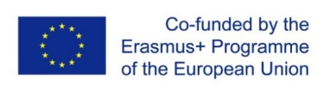
Application Deadline for the WS2023-2024 and the SS2024 is August 31, 2023.
Complete Application should be sent to AIANI (aiani@uibk.ac.at).
WE ARE LOOKING FORWARD TO YOUR APPLICATION!
For more information, please contact AIANI:
aiani@uibk.ac.at or visit our website: http://www.aiani.at/erasmus-mobility.html

