Study Abroad in Israel
Application Form

Applicant

First and Middle Name:
Last name:
Gender: female male
Birthdate, Place of Birth:
Country of Citizenship:
Expiration Date of Passport:
Home Address:
Phone Number (where applicant can be easily reached):
University Email Address: @student.uibk.ac.at
Preferred Email Address - if not the Email Address above (where applicant can be easily reached!):
Matriculation Number/Student Number at LFUI:
Field of Study/Studies:
Program of Study/Studies (BA, MA, Diploma, Teaching Program, Other):
Current Number of semester:
Degree Earned (for MA and PhD students only):

I am applying for the following semester:
Summer Semester 2023 (March 2023 – July 2023): □
Winter Semester 2023/2024 (October 2023 – February 2024): □

Please rank all partner universities according to your preferences:
[Bar-Ilan University, Beit Berl College, Ben-Gurion University, Holon Institute of Technology, Reichman University - not Erasmus, ORT Braude College (only summer semester), Tel Aviv University, The Hebrew University of Jerusalem]
1. 2. 3.
Emergency Contact

First and Last Name:
Relationship of Contact Person:
Phone Number:
Email Address:
Address:

Study Abroad Information
Did you previously participate in any exchange/mobility activity (for example Erasmus etc.)? If yes, please indicate the program, date and length:

Please write one to two paragraphs, stating your reasons for your application to study in Israel:

Statement of Costs

How much money do you overall estimate to spend for your semester abroad?

How do you plan to finance your semester abroad?
Please indicate your family’s total annual netto household income:

I will apply for a scholarship (additionally to the Erasmus+ scholarship) at (name of institution/department). Amount granted: yes no reasons:

I receive a study grant (Studienbeihilfe): yes no
Any other information or comments:

City, Date Signature of the Applicant

Please submit your COMPLETE application no later than
September 10, 2022 for the Summer Semester 2023
AIANI – Austria Israel Academic Network Innsbruck
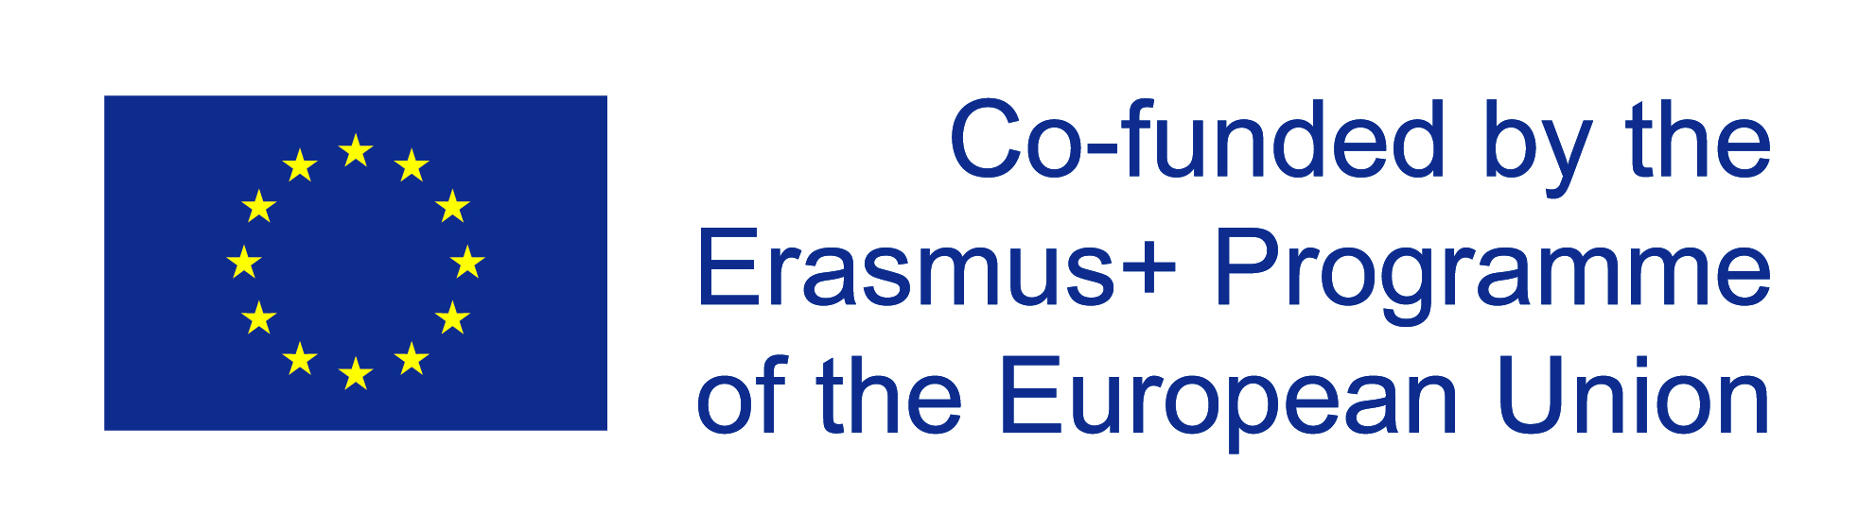
University of Innsbruck
Herzog-Friedrich-Straße 3, 1. Stock, 6020 Innsbruck
Email: aiani@uibk.ac.at

